**Disability Mela**

**Date: 11 December 2015**

**Venue: ITI campus, Palanpur, Gujarat**

As part of the Disability Mela at the district level, Employment Fair was organized for persons with disabilities. The program was organized in collaboration with District Employment office in Banaskantha. The main objective of the program was to give jobs to persons with disabilities in the district. 11 different companies were invited for the program.

The program began with lighting the lamp by the Chief Guest Dr. Johann, Head of Cooperation, European Union, BPA management and other Government officials. Mrs. Vimal Thawani, Project Director, spoke about the SVJ project, its objective and different activities. Mr HH Gadhvi, District Employment Officer, shared his perception for PWDs among community. Mr. Manish Joshi, District Social Defense Officer, informed the PWDs about the new scheme for PWDs like marriage allowance. Mr. Gaurab Sen, Project Manager, GLRA gave motivational speech to participants. Mrs. Nandini Rawal, Executive Director, BPA, gave motivational speech to invited participants. Interviews were held after the stage function.

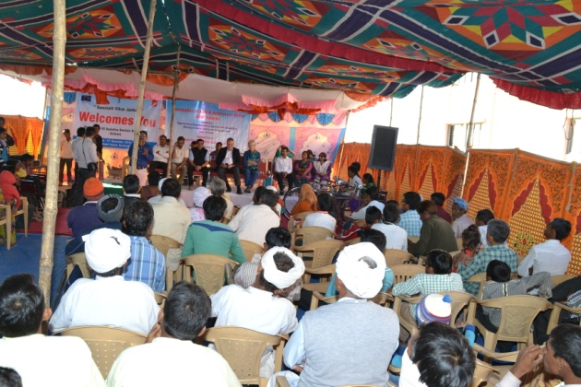 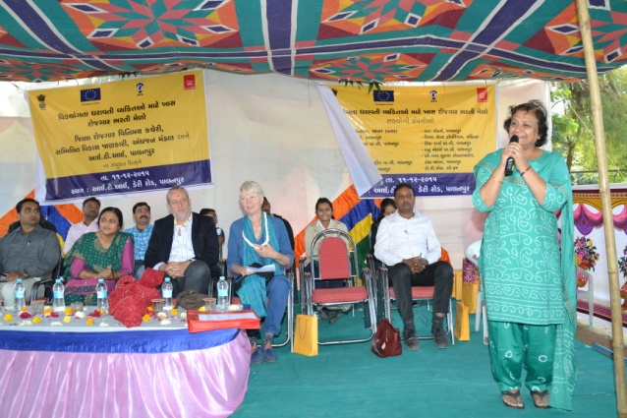

**Distribution of Assistive Devices to PWDs and release of Annual Planner of SVJ**

Assistive devices distribution to PWDs was organized the same day at Dantiwada block under the ADIP scheme of Ministry of Social Justice and Empowerment of Persons with Disabilities. Total 107 PWDs benefited for different devices distributed by Dr. Johann, President of respective Taluka Panhayat, Block Primary Education Officer and BPA management.

The Annual Planner of the SVJ project Banaskantha was released by Dr. Johann

