**International Day for the PWDs**

**Date**: 02-12-15 and 03-12-2015

**Venue**: SASSS Sendhwa Premises, Dist- Barwani. And Football Ground Barwani.

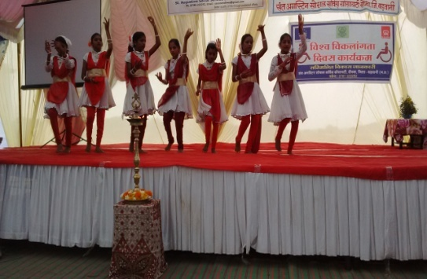

**Total Participants**: 800, and 300

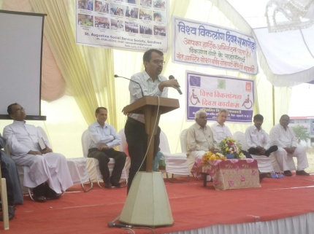**Proceedings 02-12-2015**:- The programme started with the prayer dance which is performed by Students of Nirmala Convent Sendhwa.

Facilitation of guests was done by Sr. Julia, Sr. Rani and Mr Sachin Patidar.

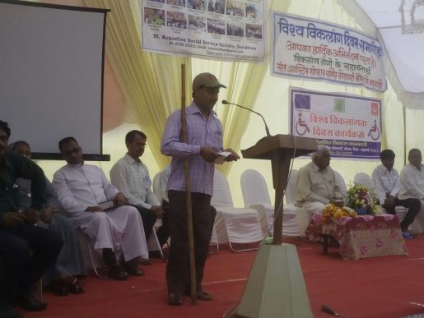Audience was addressed by Mr. Rollent Muller from BMZ, Germany, Mr Yadav, Socialist, Mr Gaurab Sen Project Manager, SVJ, Mr ML Kanel SDM Sendhwa, Mrs Asha Parmar Tehsildar, Sendhwa, Fr. Methew, Ms Dwarki Jamre, Vice-President of Madhya Pradesh Viklang Munch.

In the Program information about schemes and services was given by Mr Libin. Mr. Narendra Rathore Member of DPF Barwani sang a motivational song. Mr. Bhagwan Rawat, DPO Leader of Pati Block recited a poem. Niwali Block DPO members performed a dance.

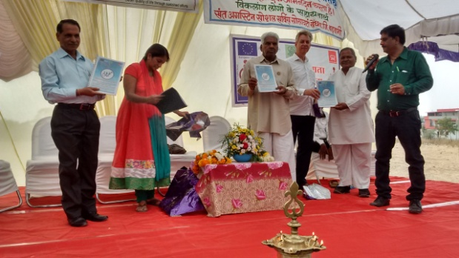In the programme assistive devices were distributed to PWDs by the organisation. In the program Scheme Booklet 2 was released by the guests.

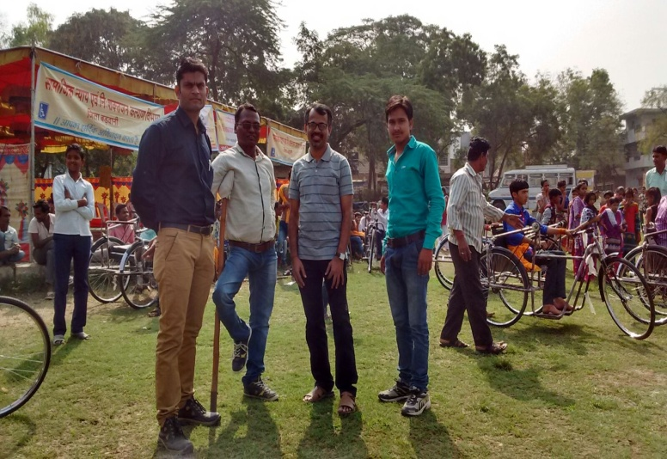**Proceedings 03-12-2015**: The programme started with the welcome of guests which is hosted by Social Justice Department Barwani.

Facilitation of guests was done by Mr J R Ahirwar and Dr Vijaya Sakpal.

Audience was addressed by Mr S Solanki from NSS, Mr Sachin Dubey from DDRC, Dr Vijaya Sakpal and Mr JR Ahirwar.

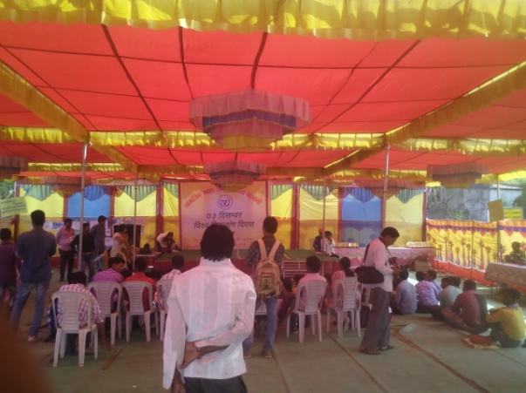In the Program Tricycle competition was held, Race and Dance was performed by PWDs of Barwani District,

Medical Team, PRO Mr Silawat, Mr Gaurab Sen, Mr Sachin Dubey, Mr Manish Sharma were present in the program.

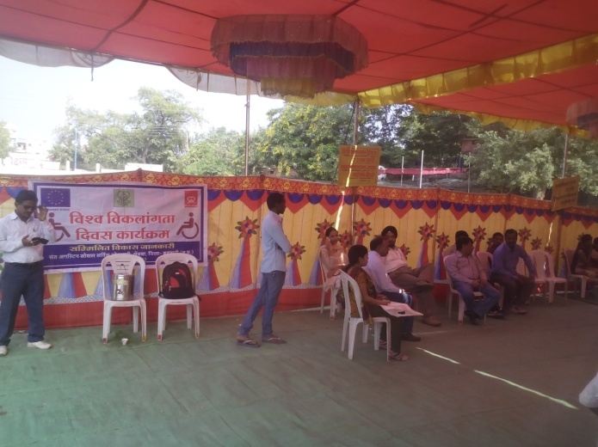In the programme prizes are distributed to PWDs by the Department .Participants shared their experience. Program ended with happy Memories.